Implementation of 8-Puzzle Problem Using Python
Aim
To solve the 8-Puzzle problem by moving the tiles from the initial state to the goal state.
Objective
- To arrange the tiles in the correct order.
- To move the blank space (0) to generate new states.
- To reach the desired goal configuration.
- To find a valid solution path from start to goal.
- To understand state-space representation in Artificial Intelligence.
ALGORITHM
- Define the initial state of the puzzle.
- Define the goal state.
- Locate the blank space (0).
- Move the blank space in possible directions (up, down, left, right).
- Generate new puzzle states after each move.
- Continue exploring new states.
- Compare each state with the goal state.
- Stop when the goal state is reached.
- Display the sequence of states leading to the solution.

PYTHON CODE:
from collections import deque

goal = [1, 2, 3,
4, 5, 6,
7, 8, 0]

start = [1, 2, 3,
4, 0, 6,
7, 5, 8]

def get_neighbors(state):
neighbors = []
pos = state.index(0)

moves = {
0: [1, 3],
1: [0, 2, 4],
2: [1, 5],
3: [0, 4, 6],
4: [1, 3, 5, 7],
5: [2, 4, 8],
6: [3, 7],
7: [4, 6, 8],
8: [5, 7]
}

for move in moves[pos]:
new_state = state[:]
new_state[pos], new_state[move] = new_state[move], new_state[pos]
neighbors.append(new_state)

return neighbors

def solve_puzzle(start, goal):
queue = deque([(start, [])])
visited = []

while queue:
state, path = queue.popleft()

if state == goal:
return path + [state]

if state not in visited:
visited.append(state)

for neighbor in get_neighbors(state):
queue.append((neighbor, path + [state]))

solution = solve_puzzle(start, goal)
print("Solution Path:")
for step in solution:
print(step[0:3])
print(step[3:6])
print(step[6:9])
print()
OUTPUT:
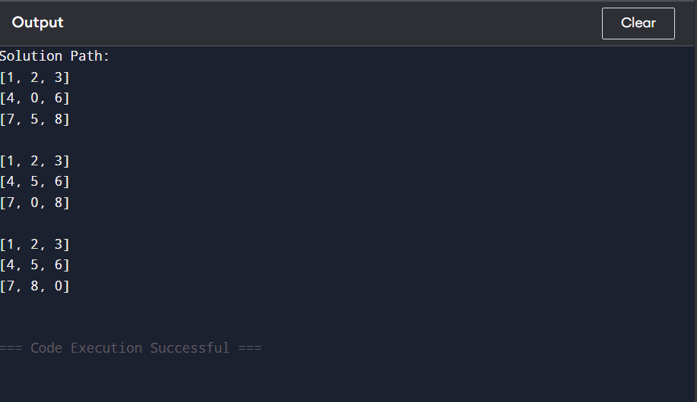

FLOW CHART:

Result
Thus, the 8-Puzzle problem was successfully solved and the goal state was reached.

